- Stage 1: Topic Selection
Clearly state your research topic/question:

How can the Iona diary be improved?

Stage 2: Data Planning
a) What type of data will you collect? (Quantitative vs Qualitative)

I will gather both quantitative and qualitative data; in inteviews I will ask my interviewee, their opinion on the A4 size of the diaries and their reaction will be recorded and described.

b) Identify appropriate data-gathering techniques:

Interview
Surveys

c) Justify why these data-gathering techniques will be useful:

Preforming interviews will give me a deeper understanding of the data being collected and it will have more depth, however the survey is easier to preform, faster and collects a greater size of data.

Stage 3: Data Collection Strategy
a) What tools will you use to collect and store your data?

I will store my data on my personal school laptop (more specifically excel), and the interview recording on my personal laptop as well.

b) How will you keep your data secure?

To keep my data secure I will change my laptop password to at least 11 characters with capitals, lowercase, numbers and special characters. I will also physically protect it by securing it at home under my bed when not in use.

Stage 4: Material Creation
Create the following materials for your research:

a) Participation Information Statement / Consent Form
Read pages 18-22 of the Nelson Textbook and create a Participation Information Statement for your project.

IONA COLLEGE – SURVEY CONSENT FORM
How Can We Improve the Iona Diary
Researcher: Evan Sariego
This project aims to gather student feedback to identify ways to improve the Iona Diary. Your insights will help guide future updates and ensure the diary better supports student organisation and wellbeing. You are invited to complete a short survey (7 Questions). We ask that all responses be provided with honesty and earnest effort so the findings accurately reflect student experiences.
Participation in this study is entirely voluntary. You may withdraw at any time and for any reason, without penalty or explanation. If you choose to withdraw, any information you have provided will not be included in the study.
Your identity will be preserved throughout the project. No personally identifying information will be collected. The only data gathered will be:
- Year level
- Gender
- Class
All information will be used solely for the purpose of improving the Iona Diary and will remain confidential.
By signing below, you acknowledge that you have read and understood the information provided above. You consent to participate in this study and understand that you may withdraw at any time.
I consent to participate in this study.
: _______________________

b) Data Collection Materials
Design appropriate materials (interviews, surveys, observation forms, etc.) based on your chosen data collection methods.

https://forms.office.com/Pages/ResponsePage.aspx?id=IH8EpR0r10KibQ4hn2Nt47HjPMurKt9Bl2Wim8fddu9UNEpJN0owN0hTTjA0RFJON1BWRTNRNFIyVC4u



Interview Questions

<<Interview questions Iona Diary.docx>>



Stage 5: Data Collection and Analysis
1. Collect responses/data using your created materials
2. Import data into Excel
3. Validate data quality by checking:
• Accuracy and reliability
• Relevance and timeliness
• Bias and completeness
4. Clean data by removing errors, duplicates, or irrelevant entries
5. Manipulate data using appropriate Excel functions to extract meaningful information
6. Analyse data using descriptive statistics (average, median, count, standard deviation, etc.)
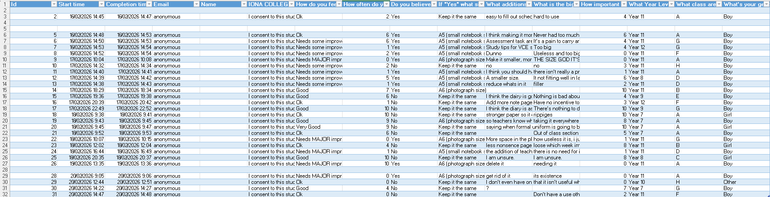
- (gaped data was removed for invalidity; e.g. bias, logical failure, inaccuracy and relevance)
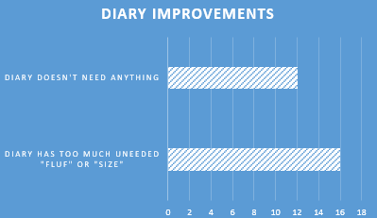
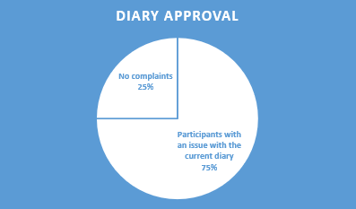
Stage 6: Presentation
Create the following deliverables:

1. Data Visualisations - Charts, graphs, or infographics representing your findings
2. Excel Dashboard - Interactive dashboard displaying key insights
3. Written Summary - 100-200 word summary of your data, analysis, and findings
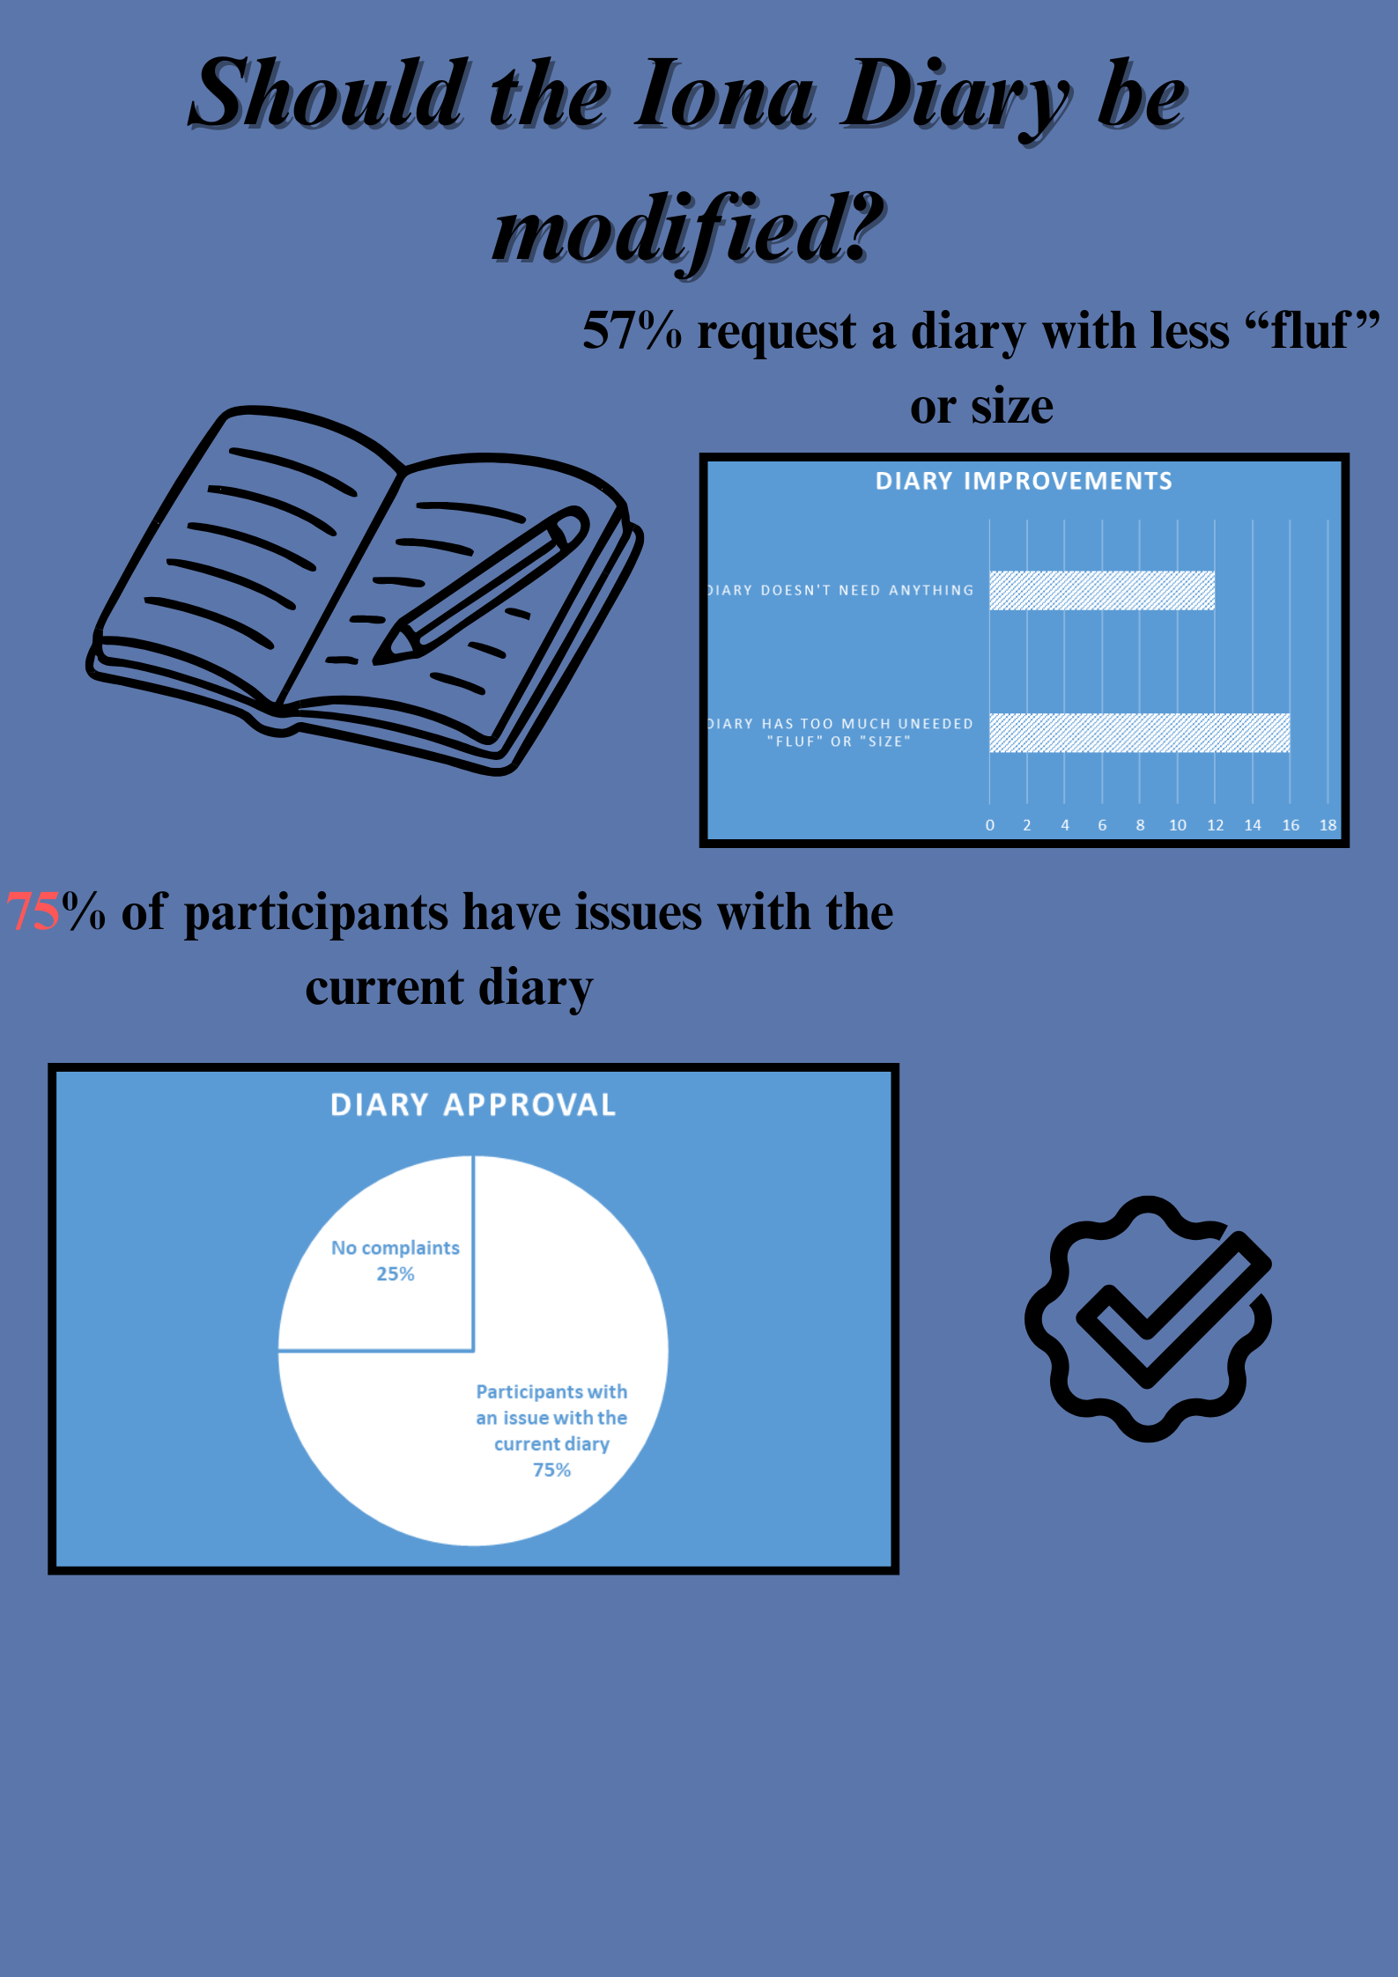

Assessment Criteria
This assessment addresses the following key areas:

• Interpretation of solution requirements, constraints, and scope
• Application of legal and ethical considerations (Australian Privacy Principles)
• Use of APA referencing system
• Statistical analysis to identify trends and patterns
• Application of functions, formats, and conventions in databases and spreadsheets
• Creation of effective data visualisations
• Data validation and testing techniques

Submission: All completed tasks must be submitted as a digital folio by the due date specified by your teacher.

